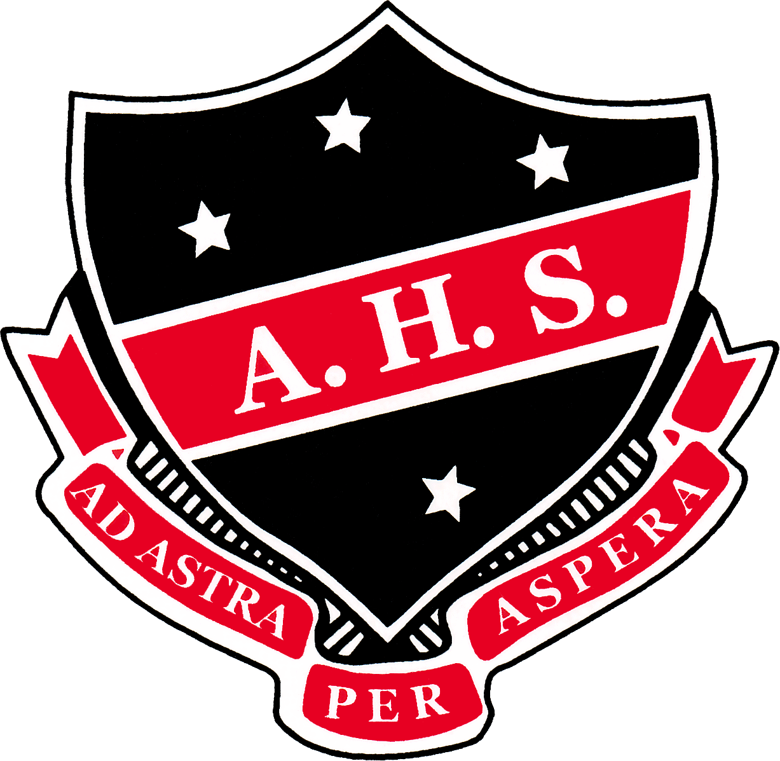
2018 INTERNATIONAL COMPETITIONS AND ASSESSMENTS FOR SCHOOLS (ICAS)
ICAS is an independent, skills-based assessment program which recognises and rewards student achievement. ICAS is unique, being the most comprehensive generally available suite of academic assessments for primary and secondary school students. The assessments comprise eight Digital Technologies tests, eleven English tests, eleven Math tests, eleven Science tests, six Spelling tests and ten Writing tests.
The competitions are challenging but rewarding and provides an opportunity for students to gain a measure of their own achievement in an external assessment situation.
All students receive a certificate and an individual report indicating which questions they answered correctly, their total score as well as their average compare with the rest of the students in the state. The student report is also useful for highlighting student strengths and weaknesses in the various areas.

2018 ICAS Dates & Prices
ICAS SUBJECT | AVAILABLE FOR YEARS | ICAS SITTING DATE | ADVERTISED PRICE | PRICE YOU PAY
Digital Technologies | Years 7 to 10 | Tuesday,8 May 2018 | AUD 9.90 | AUD 7.00
Science | Years 7 to 12 | Tuesday, 29 May 2018 | AUD 9.90 | AUD 7.00
Spelling | Year 7 | Wednesday, 13 June 2018 | AUD 13.20 | AUD 10.00
Writing | Years 7 to 12 | Thursday, 14 June 2018 | AUD 19.80 | AUD 17.00
English | Years 7 to 12 | Tuesday, 31 July 2018 | AUD 9.90 | AUD 7.00
Mathematics | Years 7 to 12 | Tuesday, 14 August 2018 | AUD 9.90 | AUD 7.00

If you would like your child to participate in one, several or all of the tests mentioned above please complete the form below and return it to Jo Kearney in administration by Friday, 16 March 2018 for the Digital Technologies or by Friday, 13 April 2018 for all other assessments. This will allow us time to submit our order and receive the paperwork in time. No late orders can be accepted.
Albury High School will subsidise all Entries received. Unfortunately, no refunds can be provided for students who are absent from school on the set test dates and make up test dates are not available.
Darryl Ward
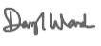
Principal

2018 ICAS Permission Slip
Please return THIS section with the correct cash payment to Jo Kearney, Administration.
I give permission for my child __________________________________________________ of Year__________
Child’s Name

To participate in (please tick ) Digital Technologies Science Mathematics
Writing Spelling English
Please find enclosed $ ______________ entry fee. _________________________________________ .
Signature of Parent/Guardian

